Activity NO.08
Aim: Execution of Network Configuration Commands.
Software: Command Prompt
Theory:
Network configuration is the process of assigning network settings, policies, flows, and controls. In a virtual network, it's easier to make network configuration changes because physical network devices appliances are replaced by software, removing the need for extensive manual configuration.
To check my network configuration:
Select the Start button, then type settings. Select Settings > Network & internet. The status of your network connection will appear at the top. Windows 10 lets you quickly check your network connection status.
Procedure:

Network Configuration Procedures
- IP address of each network interface on every machine.
- Host names of each machine on the network.
- NIS, NIS+, or DNS domain name in which the machine resides, if applicable.
- Default router addresses.
- Subnet mask (required only for networks with subnets)
hostname :
The HOSTNAME command displays the hostname of the system. The hostname command is much easier to use than going into the system settings to search for it.
Command to enter in Prompt – hostname

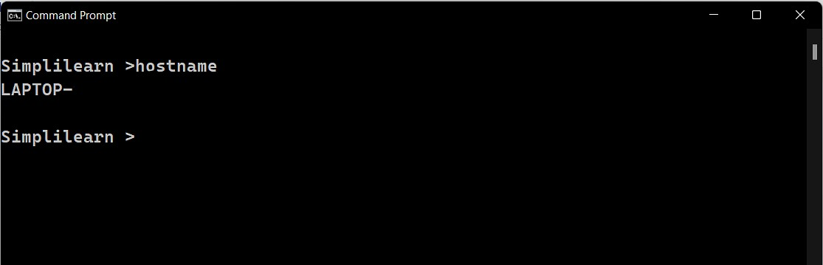
systeminfo :
Using the SYSTEMINFO command, we can access the system’s hardware and software details, such as processor data, booting data, Windows version, etc.
Command to enter in Prompt - systeminfo

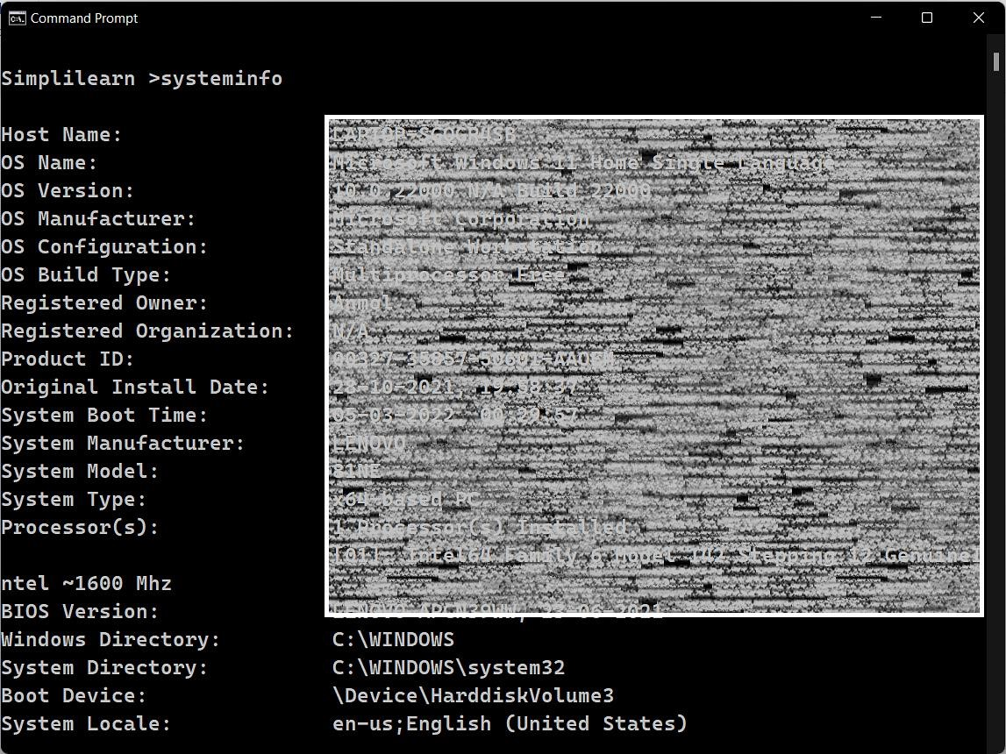
nslookup :
The NSLOOKUP command is used to troubleshoot network connectivity issues in the system. Using the nslookup command, we can access the information related to our system’s DNS server, i.e., domain name and IP address.
Command to enter in Prompt – nslookup

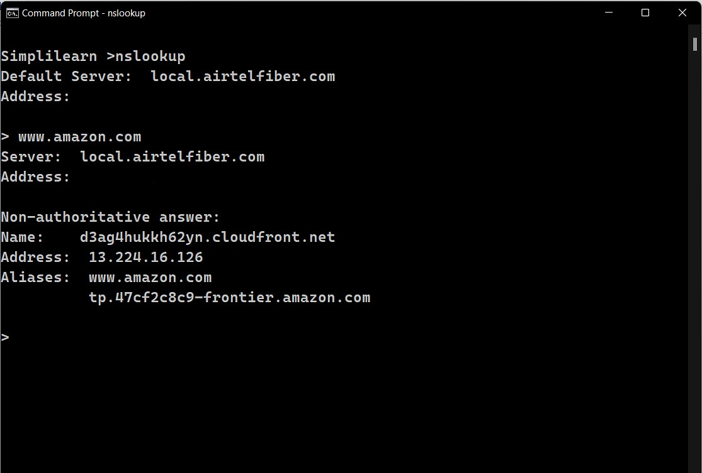
getmac :
When you’re on a Windows system and want to know the physical addresses (MAC addresses) of your network adapters, `_{getmac}` is your go-to command.
Just type `_{getmac}` in the command prompt. It reveals the unique identifiers for your network adapters, making it useful for network troubleshooting and verifying that each device has its own distinct digital fingerprint.

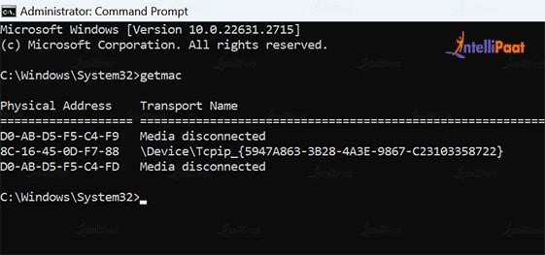
nbtstat :
When you want to know details about NetBIOS over TCP/IP, just type `nbtstat` in the command prompt. This command reveals information like NetBIOS names, IP addresses, and the current state of your NetBIOS over TCP/IP connections. It’s a handy tool for troubleshooting and understanding the NetBIOS side of your network interactions.
This command only works when the Internet Protocol (TCP/IP) is installed on a network adapter in Network Connections.
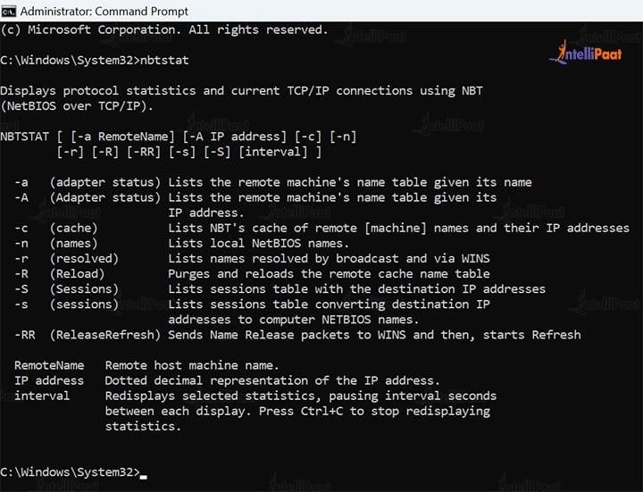
pathping :
Think of PATHPING as your network explorer. When you’re curious about the route your data takes to reach a destination and want more detailed insights than a regular traceroute, use `pathping`.
Just type `pathping` followed by the destination address, and it not only traces the route but is also used to locate spots that have network loss and network latency.
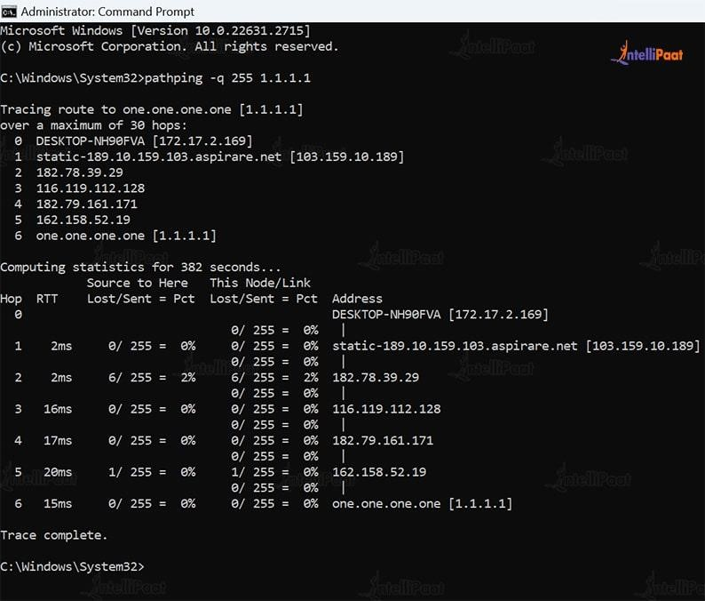
route print :
The Command route print prints the list of All Interfaces and the IPv4/v6 Routing Table. It is followed by a comma-delimited argument, which describes the command to run (e: -f). If there are no arguments then it reports all installed ports for each configured interface; if not supplied this would report only the ones present on that port range. The format uses spaces as normal in names. Below is the Snapshot after running route print on Windows.
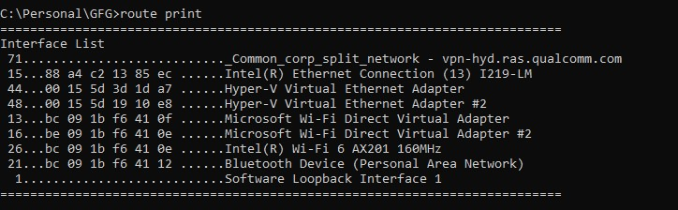
netsh :
Netsh is a command-line scripting utility that allows you to, either locally or remotely, display or modify the network configuration of a computer that is currently running. Netsh also provides a scripting feature that allows you to run a group of commands in batch mode against a specified computer. Netsh can also save a configuration script in a text file for archival purposes or to help you configure other servers. To run a netsh command, you must start netsh from the Cmd.exe prompt and change to the context that contains the command you want to use.

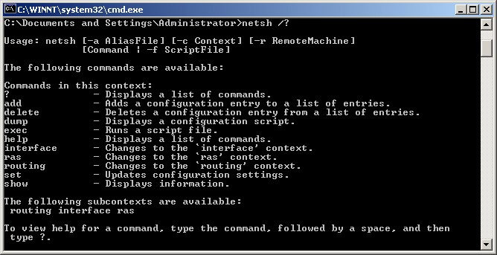
curl, curl --help :
After you create a network, copy its network ID. You use this ID to create a subnet and boot the server. Copy the id value from the output. You will use this value when you create a subnet, provision your server, or perform other related activities.
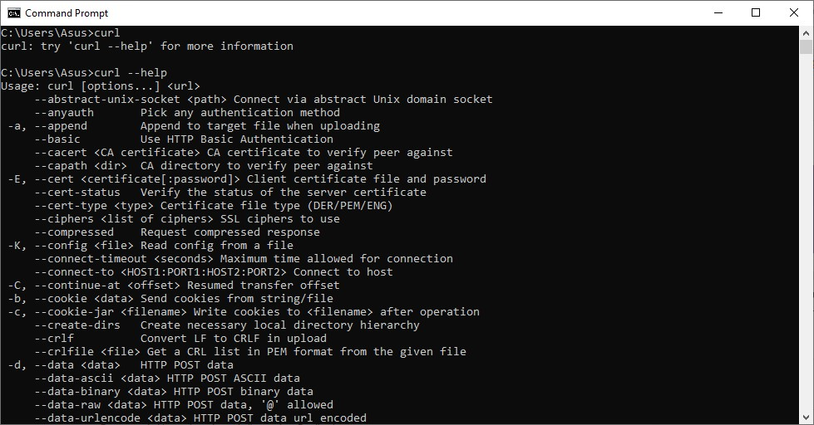
Color help :
This command is used to change the color of the command prompt. It gives various colors and the user can change accordingly. You have to type color help and then choose from the appeared screen by starting the command with color A or color 3. It helps in making the command prompt user friendly and making the screen according to user choice.
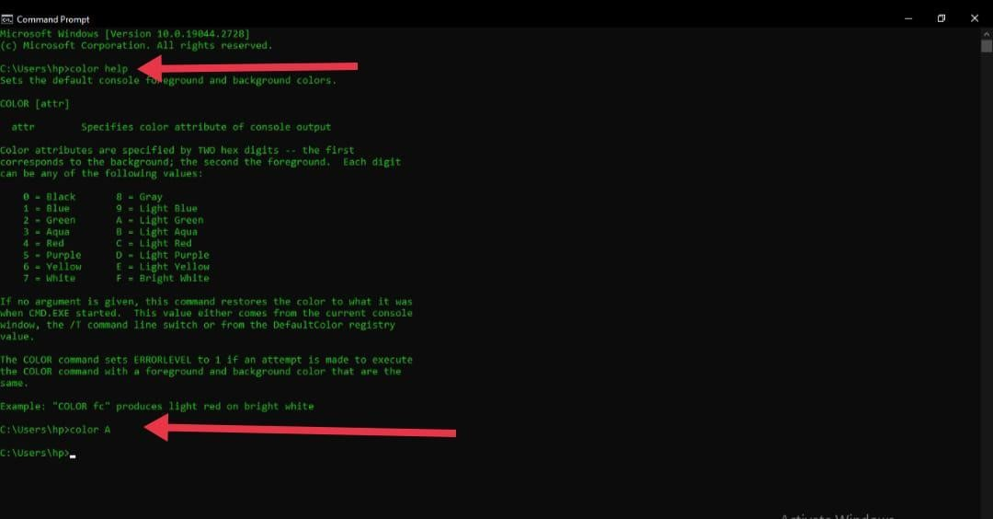
Result:
In this way, we studied and execute Network Configuration command.

